Does Commuter’s Impact on Social and Economic: Daylight Activities in Sukabumi City

Elan Eriswanto¹, Alhidayatullah²

¹ Accounting, Economics of Faculty, University of Muhammadiyah Sukabumi, Indonesia

² Management Retail, Economics of Faculty, University of Muhammadiyah Sukabumi, Indonesia

Correspondent Author: alhidayatullah@ummi.ac.id

Article history: received April 13, 2023; revised April 20, 2023; accepted June 10, 2023
This article is licensed under a Creative Commons Attribution-ShareAlike 4.0 International License


ABSTRACT

Commuter or Indonesian "nglaju" is a form of non-permanent mobility that is growing rapidly, especially in big cities in Indonesia. With this commuter, of course, there are several impacts caused, which include population mobility, economic growth, and employment. The purpose of this study is to provide an overview to the Sukabumi City government regarding the social and economic impact of commuter activities in Sukabumi City. This study uses qualitative data analysis techniques, namely data analysis carried out simultaneously with data collection or at the time of observation and interviews, where the population is residents of Sukabumi City and residents outside who are active in Sukabumi City as many as 385,710. The sampling technique uses a web raosoft.com sample size with a data accuracy level of 95% and a margin of error of 5%, then a sample of 384 respondents was obtained. This study’s data collection method uses literature studies, observations, and interviews. This commuter has an impact on increasing the number of residents during the day by 33,844 people or 9.6%. And the significant socio-economic impact in Sukabumi City resulted from shopping, culinary, and education activities by 69.5%. This means that 49.3% of commuters who carry out their activities in Sukabumi City have the purpose of shopping and culinary centers. This result, certainly has an impact on economic activities in Sukabumi City, especially the MSME economy, namely the increase in income from MSMEs. This research examines the social and economic impact of commuting and contributes to expanding the literature on commuting and the economics of community activity.

Keywords: Commuter Activities, Population Mobility, Economic Growth, Social Economic, Sukabumi City

INTRODUCTION

The dynamics of people's daily activities are activities that are always carried out regularly by the community, both in urban and rural areas. Daily activities in the city are higher than in the countryside, and many villagers are active in the city every day (Røe & Sagberg, 2017). This condition certainly results in an increase in the number of urban people during the day. The current literature states that 3 key dimensions are important in the dynamic analysis of commuter decisions and flow pattern behavior, namely flow patterns that depend on the time of day, daily dynamics of commuter decisions, and real-time dynamics. Capturing time- and daily time-dependent patterns of daily commuters in real-time faces many technical challenges given (Klinger et al., 2018) the highly fluctuating and widely generated data on community activity in high frequency. There is a broad need to harness the environment as well as people's ability to analyze the dynamics and behavior of the wider community (Majumdar, 2019)

Sukabumi City, West Java Province, Indonesia, is an area directly adjacent to Sukabumi Regency and Cianjur Regency. Where Sukabumi City is the center of Trade, Education, and Banking, while Sukabumi Regency is the center of industry. The population of Sukabumi City based on population data from the Ministry of Home Affairs has a total population of 353,631 people. Where there are around 1,765 people active outside Sukabumi City, such as Bogor and Jakarta.

Commuting or Indonesian "nglaju" activities are a form of non-permanent mobility that is growing rapidly, especially in big cities in Indonesia. Commuting activities certainly have an impact on the development of origin and commuter destinations, such as increasing transportation access and employment. Therefore, it is necessary to establish a data tool that can capture the phenomenon of commuting so that it becomes an input for the formulation of policies related to commuting. One is to provide commuter data through commuter surveys. Population commuting from buffer districts namely Sukabumi Regency and Cianjur Regency will have an impact on the number of residents during the day and night. The number of active residents during the day will be more than at night, so supporting facilities such as transportation, public, and shopping centers are needed (Wang et al., 2020).

Commuters from outside Sukabumi are not just traveling, and exercising but working and going to school and others so these activities have a huge impact on economic development and social aspects in the environment of Sukabumi City. Residents outside the city of Sukabumi who work in the city of Sukabumi will bring part of their income to spend outside the city of Sukabumi and vice versa residents outside the city of Sukabumi who travel, exercise, and go to school will shop in the city of Sukabumi, so it needs to be surveyed and analyzed so that it is clear between the funds that enter the city of Sukabumi and the funds that come out of the city of Sukabumi. With this commuter, of course, there are several impacts caused, which include population mobility, economic growth, and employment. The purpose of this study is to provide an overview to the Sukabumi City government regarding the social and economic impact of commuter activities in Sukabumi City.

The introduction should identify key ideas of the research, why it is important, pose a research question that needs to be answered, and how the findings contribute to the discipline. The introduction includes the description of the study, problems, sets aim and tasks of the research, research methods applied, and presents novelty and topicality of the research as well as lists problematic questions of the conducted research, information sources, delimitations of research subjects, and theoretical discussion.

LITERATURE REVIEW:

Commuter

Commuter comes from the English Commuter, which is a term for someone who makes a daily trip from residence to work or school, usually using modes of transportation such as trains, buses, or private vehicles. (Mahmood et al., 2017). The term commuter is usually used to describe the daily travel habits or patterns of someone who travels long distances from home to work or school and returns home at the end of the day. Commuters or commuters are usually closely related to urbanization activities and the development of cities that are increasingly developed and developed, and require high mobility. (Qiu & Cao, 2020) A commuter himself in Indonesian called a komuter or commuter is someone who travels to a city for work and returns to the city where he lives every day. This activity is carried out because a person has a place to live that is quite far from where he works. The meaning of commuter comes from the word "nglaju" which means to go to another place, generally do a job, and have no plans to stay overnight at the destination (Ahmed et al., 2019). A commuter itself can be interpreted as a person who lives outside the boundaries of neighborhoods and goes to the village every morning, and returns in the afternoon (Jang &; Ko, 2019).

Meanwhile, commuting, also known as “nglaju” is the movement of residents from the origin area to the destination within a certain time limit and returning to the origin area on the same day (Mantra, 2004). In general, people who do mobility want to return to their area of origin as soon as possible so when compared to the frequency of people who do shuttle mobility, overnight / lodge, and migration, the frequency of mobility of shuttle residents is the largest followed by overnight / lodge and migration (Xue et al., 2019). People who do it are called commuters or commuters. For example, people who work in Jakarta but reside in Bogor, Depok, Tangerang, and Bekasi. They are called commuters if they travel from their place of residence to their place of work almost every day round trip.

Commuter groups, according to them, usually choose to live in the (Tamin, 2008) hinterland around their mother city. Most of them have jobs in the mother city so they commute every day and do a shuttle every day. Commuter movement is limited only to work activities which are classified as a classification of movement due to economic activity. Urban elves are zones in the transition area of urban villages which he called regional cities, namely an area not only covers areas with rural functions but also urban functions and a mixture of the two (Qiu & Cao, 2020). According (Yunus, 2008) Found 4 frame zones in the peri-urban area that can be applied to developing cities in developing countries, including:
- City frame zone (Zobikot), with a value range of >75% to 25% to >0% rural land.
- Rural-urban frame zones (Zobikodes), with values ranging from 50% to 25% to 50% to 25% of urban land.
- Urban village frame zone (Zobidekot), with a value range of >50% to 25% urban land.
- Village frame zones (Zobides), with values ranging from >75% to 100% rural land, and 0% urban land

Population Mobility
Population mobility can be interpreted as the movement or movement of a population from one place to another within a certain period. Population mobility can occur due to various factors, such as finding a job, seeking a better education, and improving the quality of life, or due to other factors such as natural disasters or political conflicts (Adane & Gawande, 2020). Population mobility can occur on a local, regional, or international scale. Local-scale population mobility is the movement of people from the city to the suburbs or vice versa. Meanwhile, regional-scale population mobility is the movement of population from one region to another within a country or region. Meanwhile, international population mobility is the movement of people from one country to another for various reasons such as study, work, or migration.

Population mobility can have both positive and negative impacts on the social and economic life of the people in the area concerned. Therefore, population mobility needs to be regulated and managed properly to provide maximum benefits to the community and minimize negative impacts that may arise (Kim &; Lee, 2015). In essence, population mobility is a reflection of differences in growth and uneven development facilities between one region and another (Krall et al., 2021). People from areas with fewer development facilities will move to areas that have better development facilities. Routine movement of places (mobility) serves to complement each other (complementary) and there is a movement that can be interpreted as interaction. The interaction that takes place between one region and another occurs in certain stages and distances to cause spatial patterns (Majumdar & Mitra, 2019b)

There are several theories related to mobility, namely:
- Mobility and distance mean a lot of mobility at short distances due to a sense of attachment to the family left behind and long-distance mobility is more directed towards important trade and industrial centers.
- Current and reverse current means that each major mobility current gives rise to its replacement backflow.
- Technology and mobility mean that technology causes mobility to increase.
- Economic motives are the main impetus for people to move

Economic Growth
Economic growth is the added value of the total production of goods and services within a country or region within a certain period. Economic growth is usually measured using the GDP (Gross Domestic Product) indicator which includes the total value of all goods and services produced within a country in a year (Torrente et al., 2019). Economic growth can be interpreted as an indicator of the progress and welfare of a country or region. High economic growth indicates that the economy of a country or region is developing well, measured by increasing production output, increasing investment, increasing employment, and increasing people's income (Davidai, 2018). However, economic growth also has social and environmental impacts that can affect the sustainability of a country's or region's development. Therefore, it is important to pay attention to aspects of sustainable development in carrying out economic policies, so that economic growth can run in balance with efforts to preserve the environment and sustainable social development (Goudswaard & Caminada, 2016).

According to (Adisasmita, 2013) economic growth, is an effort to increase production capacity to achieve additional output, which is measured using Gross Domestic Product (GDP) and Gross Regional Domestic Product (GDP) in a region. Economic growth is the process of increasing per capita output in the long run. The emphasis is on three aspects, namely: process, per capita output, and long run. Economic growth is a process, not an economic picture at any given moment. Here we look at the dynamic aspects of an economy, namely how an economy develops or changes over time. The pressure is on the change or development itself (Boediono, 1999).

Then (Todaro &; Smith, 2013) revealed from various existing growth theories, namely the theory of Harold Domar, the Neoclassical, from Solow, and the endogenous theory by Romer, that there are three main factors or components in economic growth. These three are:

a. Capital accumulation, which includes all new forms or types of investments invested in land, physical equipment, and capital or human resources.

b. Population growth, which in the next few years will increase the number of the labor force.

c. Technological advances in regional development are carried out to achieve three important goals, namely achieving growth, equity, and sustainability.

Labor force and economic growth

The labor force is the amount of labor available in a country or region consisting of residents who are 15 years of age or older and can work or are looking for work (Duc Tai, 2022). The labor force includes the employed workforce and the workforce that is looking for work or is unemployed. Labor Force and Economic Growth According to population growth (Todaro &; Smith, 2013) AK growth is traditionally considered one of the positive factors that spur economic growth. A larger workforce means more production, while greater population growth means a larger domestic market. However, it is still questionable whether it is true that the rapid rate of population growth will have a positive or negative impact on economic development.

The positive or negative impact of population growth depends on the ability of the economic system of the region to absorb and productively utilize the increase in labor (Yang et al., 2021). This ability is influenced by the level and type of capital accumulation and the availability of inputs and supporting factors such as managerial and administrative skills. In a simple model of economic growth, in general, the notion of labor is defined as a homogeneous labor force. A homogeneous and unskilled workforce is considered to be able to move and move from the traditional sector to the modern sector smoothly and in limited quantities. In such circumstances, the supply of labor contains high elasticity. The increasing demand for labor (from the traditional sector) stems from the expansion of modern sector activities. Thus, one of the factors that influence economic growth is labor. According to that a production function of a particular good or service (q) is (Samuelson &; Willian D, 2003) q = f (K, L) where k is capital and L is labor which shows the maximum amount of a good / service that can be produced using an alternative combination of K and L if one input plus one additional unit and the other input is considered to still cause additional output that can be produced.

This additional output produced is called the marginal physical product (Marginal Physical Product). It goes on to say that if the number of labor is added continuously while other factors of production are kept constant, then at first it will show an increase in productivity but at a certain level it will show a decrease in productivity and after reaching the maximum level of output any increase in labor will reduce expenditure (Mavridis, 2018).

Work includes residents who are already or are currently working, are looking for work, and doing other activities, such as attending school and taking care of the household (Simanjuntak, 2011). According to BPS, residents aged 10 years and over are divided into the Labor Force (AK) and not AK. The labor force is said to be employed if they perform work to obtain or help to obtain income or profit and the length of work is at least 1 (one) hour continuously during the past week.

Economic growth and the labor force are interrelated. High economic growth can create new jobs and absorb the available labor force, so the unemployment rate can decrease. Meanwhile, the available labor force can also affect the economic growth of a country or region, as the amount and quality of available labor can affect the productivity and performance of the economy as a whole (Kim & Lee, 2015). Increased economic growth is usually followed by increased employment opportunities and improved quality of life in the community. This can occur due to increased investment, increased production, and increased demand for goods and services. However, in some cases, high economic growth is not always accompanied by an improvement in the quality of life of the community, such as the occurrence of economic and social inequalities, and an increase in environmental degradation (Le et al., 2022). Therefore, there needs to be appropriate policies in economic development, including human resource management, to achieve sustainable economic growth and community welfare.

RESEARCH METHOD

In the preparation of this study, using a (Creswell, 2016) qualitative approach according to the intent of qualitative research is to understand a particular social situation, event, role, group, or interaction. It is largely an investigative process where the researcher gradually makes sense of a social phenomenon by contrasting, comparing, replicating, cataloging, and classifying the object of study. The type of research used is descriptive, which is research that aims to decrypt or explain something as it is. This study aims to provide a description or description of a situation. This study’s data collection method uses literature studies, observations, and interviews. This study uses qualitative data analysis techniques, namely data analysis is carried out simultaneously with data collection or during observation and interviews. The practical steps taken during data analysis are (1) raw data collection, which is carried out through interviews, data analysis of BPS reports and questionnaires, and literature reviews, (2) data transcripts, namely changing records to written form, (3) coding works, rereading all data that has been transcribed and retrieving keywords, (4) Data Algorithmization, simplifying data by tying key concepts (words) in one magnitude, (5) temporary conclusions, namely making temporary conclusions, (6) triangulate, checking and rechecking between one source and another data source, (7) conclusions, namely the final process of the whole step, (8) The conclusion is taken when the data is saturated and each addition of new data only means redundant. The population in this study is the population of Sukabumi City and outside who are active in Sukabumi City as many as 385,710. The sample was taken using a web raosoft.com sample size with a data accuracy level of 95% and a margin of error of 5%, so as many as 384 respondents were sampled in this study.

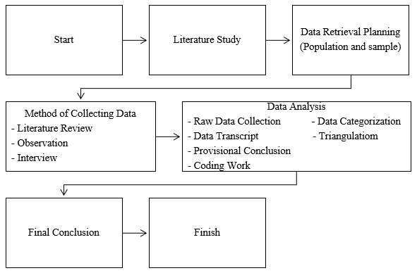

Figure 1. Research Method Diagram

RESEARCH RESULTS AND DISCUSSION:

Commuting or Indonesian "nglaju" activities are a form of non-permanent mobility that is growing rapidly, especially in big cities in Indonesia. Commuting activities certainly have an impact on the development of origin and commuter destinations, such as increasing transportation access and employment. Population commuting from buffer districts namely Sukabumi Regency and Cianjur Regency will have an impact on the number of residents during the day and night. Residents who enter from outside the city of Sukabumi have various reasons both school, using health facilities, business, work, and maybe also just a walk to enjoy the fresh air and facilities owned by the city of Sukabumi.

Characteristics of Respondents

The sample of this study was 384 respondents. The characteristics of respondents are known to be more men than women, while the age range is at 17-60 years with different destinations.

Table 1. Characteristics of Respondents

No | Information | Frequency | Percentage
1.  2.  3. | Gender  Man  Woman  Age Range  55 – 60 Years  46 – 55 Years  36 – 45 Years  26 – 35 Years  17 – 25 Years  Points of Interest  Educational Institutions  Government Institutions  Hospitality  Banking  Hospital  Traditional Market  Sports venues  Super Market  Culinary Places  Miscellaneous | 230  154  60  90  120  80  34  84  11  17  57  34  62  20  50  44  5 | 59,9%  40,1%  15,6%  23,4%  31,3%  20,8%  8,9%  21,8%  2,7%  4,5%  14,6%  9%  16,2%  5,2%  13,1%  11,6%  1,21%
Total |  | 384 | 100%

Commuter Number of Population of Sukabumi City During the Day

Population commuting is the mobility of the population from one place to another within a certain period. The mobility of the population of Sukabumi City is caused by education, work, and shopping.

Table 2. Number of Residents of Sukabumi City during the Day

Event Center | Visitors |  |  | Worker
Event Center | Sum | Regency | % | Sum | Regency | %
Educational Institutions  Government Institutions  Hospitality  Banking  Hospital  Traditional Market  Sports venues  Super Market  Culinary Places  Miscellaneous | 96.648  1.454  10.650  3.200  7.500  3.000  8.550  5.000  3.750 | 5.799  1.338  4.363  2.048  4.950  1.710  3.933  2.800  373 | 6%  92%  41%  64%  66%  57%  46%  56%  10% | 3.222  4.531  690  710  2.531  750  150  855  2.706  750 | 1.578  906  175  589  1.012  525  65  505  1.137  38 | 49%  20%  25%  83%  40%  70%  43%  59%  42%  5%
Total | 140.052 | 27.314 | 19,5% | 16.895 | 6.530 | 38,7%

Total residents outside Sukabumi City who are active in Sukabumi City 33.844

Total Population of Sukabumi City 353.631

The total population of Sukabumi City who is active outside Sukabumi City is 1.765

Total 351.866
The number of inhabitants of Sukabumi City during the day was 385.710

The table above explains that the increase in the population of Sukabumi City was 33.844 or 9.6%. Where are the educational institutions that have the biggest impact on increasing the population of Sukabumi City? The largest centers of commuter activity are educational, culinary, and hospital institutions.

Socio-Economic Commuters
Commuting, or people who travel regularly between residence and work or school, can have a significant socioeconomic impact. Commuters can make a positive contribution to the economy through fuel consumption, public transportation, and consumption of goods and services in the area they are going to. Commuters can also help improve labor mobility and allow companies to recruit employees from a wider area. Commuters have an impact on the socio-economy in Sukabumi City, namely the Department of Commerce by 3.6%, shopping at 25.5%, watching at 10.6%, culinary at 23.8%, and other destinations by 16.3%. The significant socio-economic impact in Sukabumi City resulted from shopping and culinary activities at 49.3%. This result certainly has an impact on the development of MSMEs in the culinary sector, income for supermarkets and trade, and also in other sectors.

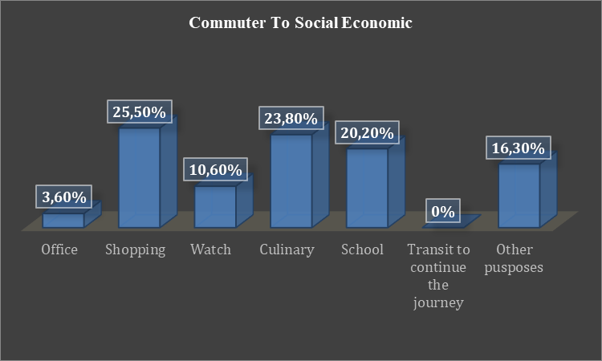

Graph 1. Socio-Economic Commuters

There were several questions asked to respondents about the impact of commuting on this socio-economy, including the amount of money spent in Sukabumi City, the location to which money was spent, the percentage of income spent, and products purchased.

The amount of money spent

The amount of money spent by commuters is grouped into 4, namely below Rp 250,000 by 57%, Rp 250,000 – Rp 500,000 by 24%, Rp 500,000 – Rp 1,000,000 by 16%, and above Rp 1,000,000 by 3%. This explains that most commuters spend Rp 250,000. The percentage of money spent can be seen in the graph below:

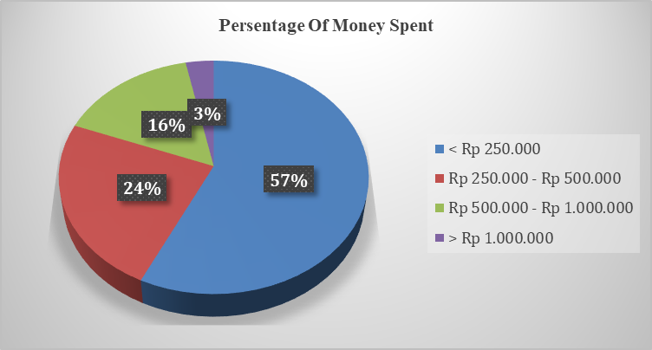

Graph 2. The amount of money spent

The location where the money is used

The locations used as destinations to use the money are traditional markets at 23.2%, malls at 26.3%, cinemas at 12.6%, culinary places at 30.8%, and others at 7.1%. Sukabumi City is an area known for its cuisine, it can be seen that the location is the destination of people who come to Sukabumi City as a culinary place. The percentage of locations where money is used can be seen in the graph below:

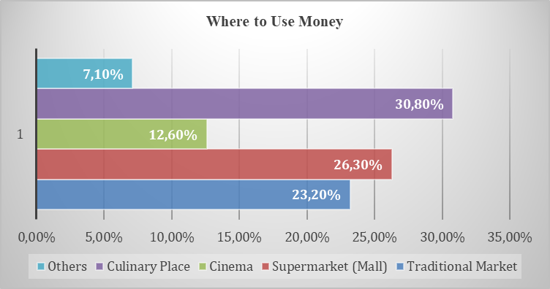

Graph 3. Where to Use Money

Percentage of income spent

The percentage of income spent by people who come to Sukabumi City every month is <20% by 10%, 20%-30% by 14%, 30%-40% by 20%, 40-50% by 14%, and >50% by 42%. This explains that the average income spent by commuters in Sukabumi City is above 50%. It can be seen in the chart below:

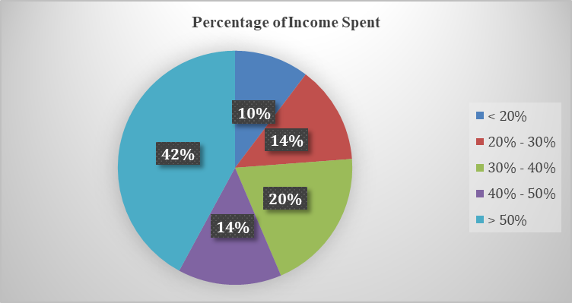

Graph 4. Percentage of income spent

Types of uses of money for spending

The types of money spent by commuters in Sukabumi City are shopping for clothes at 15.38%, culinary at 21.7%, recreation at 9.3%, necessities at 33.15%, and others at 9.34%. It can be seen that the types of money spent by commuters are necessities, culinary, and clothing shopping. It can be seen in the chart below:

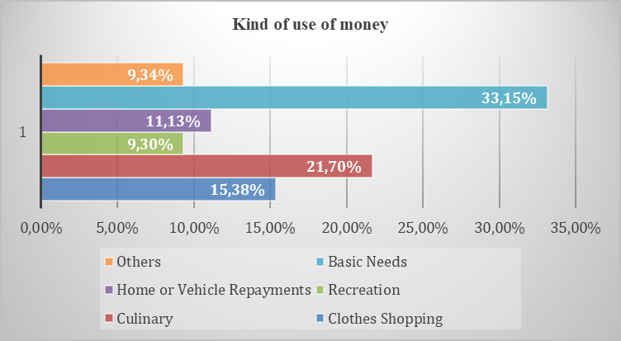

Graph 5. Types of Money Uses

Discussion

Impact of Commuters on Social (Population)

Based on observations made in Educational Institutions, Government Institutions, Hospitality, Banking, Hospitals, Traditional Markets, Sports Venues, Super Markets, Culinary Places, and others, it was found that the population of Sukabumi City during the day increased by 33,844 people by 9.6%. The population growth is dominated by educational institutions, culinary centers, and hospitals. This population increase certainly significantly impacts social aspects, namely strengthening social relations, increasing employment opportunities, and supporting economic growth. The impact of strengthening social relationships is by strengthening social relationships between colleagues or friends who carry out the same activity. The impact of increasing job opportunities is that with high mobility, commuters can open up wider job opportunities and help them find jobs that match their skills and interests. And the impact of supporting economic growth is by increasing labor mobility, allowing companies to recruit employees from a wider area, and promoting economic growth.

The Impact of Commuters on Socio-Economy

Based on the results of the interview, it was found that the impact of commuting on the socio-economy in Sukabumi City was 3.6% Office, shopping at 25.5%, watching at 10.6%, culinary at 23.8%, education at 20.2% and other destinations by 16.3%. The significant socio-economic impact in Sukabumi City resulted from shopping, culinary, and education activities by 69.5%. This means that 49.3% of commuters who carry out their activities in Sukabumi City have the purpose of shopping and culinary centers. This result certainly has an impact on the development of MSMEs in Sukabumi City, especially in the culinary, supermarket and trade, education, and also in other sectors. Commuters can have a significant impact on social and economic aspects, i.e. commuting can increase labor mobility, thus allowing companies to recruit employees from a wider area and promote economic growth. And commuters can improve accessibility to important places like downtowns, shopping malls, and other places. This can help drive economic growth and increase the attractiveness of the city.

CONCLUSIONS

Commuters have a very positive impact on the economic development of the community because they can increase income, therefore the people of Sukabumi City must be good at seizing opportunities, especially in the food and beverage (culinary) industry. The role of penta helix needs to be encouraged in the form of mutually beneficial collaboration, the government makes policies and provides training to MSMEs, and capital owners play a role in increasing their capacity and providing opportunities for MSMEs to open some outlets in supermarkets, hotels, newsmakers play a role in promoting and it would be even better for the government to have a calendar of events that are held regularly. The government can benefit from development taxes, parking, and increased public revenue from these activities.

REFERENCES

Adane, V. S., & Gawande, S. (2020). Exposure and inequity: assessing commuter vulnerability and the quality of noise environment on urban arterials. International Journal of Urban Sciences, 24(1), 110–127. https://doi.org/10.1080/12265934.2019.1652109

Adisasmita, R. (2013). Theories of Economic Development. Graha Ilmu.

Ahmed, A., Mehdi, M. R., Ngoduy, D., & Abbas, M. (2019). Evaluation of accuracy of advanced traveler information and commuter behavior in a developing country. Travel Behaviour and Society, 15, 63–73. https://doi.org/10.1016/j.tbs.2018.12.003

Boediono. (1999). Economic Growth Theory. BPFE.

Creswell, J. (2016). Research Design Qualitative, Quantitative, and Mixed Method Approaches. Pustaka Pelajar.

Davidai, S. (2018). Why do Americans believe in economic mobility? Economic inequality, external attributions of wealth and poverty, and the belief in economic mobility. Journal of Experimental Social Psychology, 79, 138–148. https://doi.org/10.1016/j.jesp.2018.07.012

Duc Tai, T. (2022). Impact of corporate social responsibility on social and economic sustainability. Economic Research-Ekonomska Istrazivanja, 35(1), 6085–6104. https://doi.org/10.1080/1331677X.2022.2046480

Goudswaard, K., & Caminada, K. (2016). THE ROLE OF CONTRIBUTIONS IN SOCIAL SECURITY COVERAGE AND FINANCING Social Security contributions: Economic and public finance considerations.

Jang, J., & Ko, J. (2019). Factors associated with commuter satisfaction across travel time ranges. Transportation Research Part F: Traffic Psychology and Behaviour, 66, 393–405. https://doi.org/10.1016/j.trf.2019.09.019

Kim, Y. J., & Lee, C. I. (2015). Social values and economic dynamics. Journal of Economic Dynamics and Control, 53, 69–84. https://doi.org/10.1016/j.jedc.2015.01.008

Klinger, T., Lenz, B., & Noll, M. (2018). How commuting affects social capital and subjective well-being in rural areas. Journal of Transport Geography, 29–36.

Krall, J. R., Moore, K. D., Joannidis, C., Lee, Y. C., Pollack, A. Z., McCombs, M., Thornburg, J., & Balachandran, S. (2021). Commuter types identified using clustering and their associations with source-specific PM2.5. Environmental Research, 200. https://doi.org/10.1016/j.envres.2021.111419

Le, T. H., Bui, M. T., & Uddin, G. S. (2022). Economic and social impacts of conflict: A cross-country analysis. Economic Modelling, 115. https://doi.org/10.1016/j.econmod.2022.105980

Mahmood, T., Mujtaba, G., Shuib, L., Ali, N. Z., Bawa, A., & Karim, S. (2017). Public bus commuter assistance through the named entity recognition of twitter feeds and intelligent route finding. IET Intelligent Transport Systems, 11(8), 521–529. https://doi.org/10.1049/iet-its.2016.0224

Majumdar, B. B. (2019). A study on route choice preferences for commuter and non-commuter bicyclists: a case study of Kharagpur and Asansol, India. Transportation, 46(5), 1839–1865. https://doi.org/10.1007/s11116-018-9898-z

Mantra, I. B. (2004). Research Philosophy and Social Research Methods. Pustaka Pelajar.

Mavridis, S. (2018). Greece’s economic and social transformation 2008-2017. Social Sciences, 7(1). https://doi.org/10.3390/socsci7010009

Qiu, Z., & Cao, H. (2020). Commuter exposure to particulate matter in urban public transportation of Xi’an, China. Journal of Environmental Health Science and Engineering, 18(2), 451–462. https://doi.org/10.1007/s40201-020-00473-0

Røe, P. G., & Sagberg, F. (2017). The impact of long commuting on subjective health complaints and sickness absence. BMC Public Health, 17(1).

Samuelson, P. A., & Willian D, N. (2003). Macroeconomics. PT Media Global Education.

Simanjuntak, P. J. (2011). Performance Evaluation Management. Faculty of Economics UI.

Tamin, O. Z. (2008). Transportation Planning and Modeling (1st ed.). ITB Bandung.

Todaro, M. P., & Smith, S. (2013). Economic Development (11th ed.). Erlangga.

Torrente, D., Caïs, J., & Bolancé, C. (2019). Economic crisis and social trust: Reviewing the effects of economic polarisation on social and institutional confidence. Social Science Information, 58(4), 631–659. https://doi.org/10.1177/0539018419891321

Wang, Y., Wang, Y., Ettema, D., Mao, Z., Charlton, S. G., & Zhou, H. (2020). Commuter value perceptions in peak avoidance behavior: An empirical study in the Beijing subway system. Transportation Research Part A: Policy and Practice, 139, 70–84. https://doi.org/10.1016/j.tra.2020.07.001

Xue, Y., Fan, H., & Guan, H. (2019). Commuter Departure Time Choice Considering Parking Space Shortage and Commuter’s Bounded Rationality. Journal of Advanced Transportation, 2019. https://doi.org/10.1155/2019/4864287

Yang, J., Tang, Z., Yuan, Q., & Xu, B. (2021). The economic and social benefits of the government-backed credit guarantee fund under the condition of an economic downturn. Technological Forecasting and Social Change, 166. https://doi.org/10.1016/j.techfore.2021.120632

Yunus, H. S. (2008). Dynamics of the Urban Fairy Area Detirminan The Future of the City. Pustaka Pelajar.

